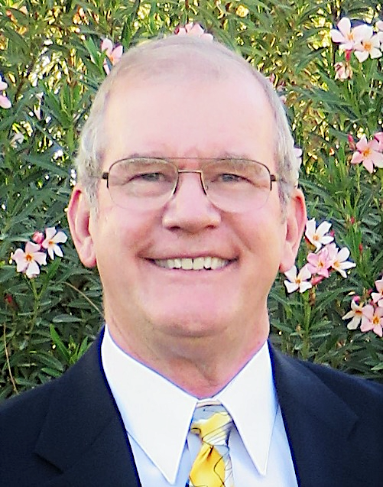
10 Willis Court (Huntwood Subdivision) – Central Precinct
Moved to Poquoson in 1994 while on active duty with the US Air Force. Worked at the US Atlantic Command at NOB Norfolk. In 1997, changed positions to work at the Joint Deployment Training Center at Fort Eustis.
Professional:
Retired US Air Force pilot (2001)
Former Admissions Counselor, Old Dominion University and Thomas Nelson Community College
Retired defense contractor, General Dynamics
Former Owner and Operator, Kids Play Safer Playground Inspections, LLC
- Certified Playground Safety Inspector (CPSI)
Keith A. Feigh
City Related Activities:
Member of Poquoson Lions Club, 2000 to present
- Twice served as Lions Club President (2004-2005 and 2010-2011)
- Initiated Club’s efforts with Poquoson Parks & Recreation Department in promoting youth soccer and providing improvements to South Lawson Park. Efforts include planting of trees at the park, installing 16 park benches and two picnic tables, building two swing sets, installing a children’s playground, and providing annual clean up and maintenance as the Park’s Adopt-a-Spot sponsor.
Member of Poquoson Parks & Recreation Advisory Board, 2012 to 2021
- Twice served as Chairman (2016-2018 and 2020-present), Vice Chairman (2013-2015).
- Oversaw Advisory Board’s input to the City’s current Comprehensive Plan and Master Infrastructure Plan. Coordinated work sessions with City Council.
- Provided professional consultation to Poquoson City Public Schools and Public Works on playground safety issues
Appointed to Poquoson City Council in June 2021 following the resignation of a council member. Elected to Poquoson City Council in November 2021, representing the Central Precinct
- Serves as council liaison with the Virginia Peninsula Foodbank
Family:
Wife, Kathy Feigh. Retired pharmacist. Former Pharmacy Manager at Hampton Walmart 1995-2010 and staff pharmacist at McDonald Army Health Center (2010-2020). Assisted with City COVID vaccinations and is currently serving on the Economic Development Authority.
Daughter, Dr. Karen Feigh. Poquoson High School graduate, class of 1997 and Marshall Scholar. Currently a Professor of Aerospace Engineering at Georgia Institute of Technology in Atlanta.
Son, LTC Steven Feigh. Poquoson High School graduate, class of 1999. Currently on active duty in the US Army, serving on the staff of the US Northern Command/North American Air Defense Command in Colorado.

Priority: The children of Poquoson
My family moved to this area because of the Air Force, but we moved into Poquoson because of my children. It was a difficult decision picking Poquoson over Tabb, but in the end, it was my rising sophomore daughter who decided upon Poquoson, hoping to not lose friends through potential school rezoning. Though she only attended Poquoson schools for three years, those years had a lasting impact on her life. Our family has not regretted that decision.
I have long favored focusing efforts on children. Whether it be sidewalks, bikeways, schools or recreational amenities, children are dependent upon us adults even though they may think otherwise. This dependency includes their physical, educational, and emotional wellbeing. Whatever it takes to help with these, I am willing to discuss it.
In early 2010, I attended a Community Group Meeting hosted by the Parks & Rec Department for all City clubs, churches, youth organizations, and others. The idea was to share information and foster mutual support for one another. Representing the Lions Club, I noted that while formal organizations existed in the City for the advancement of baseball, softball, football and cheerleading, there was none to help advance the growing soccer community. The Lions have since worked to fill that void.
I personally sold Poquoson soccer stickers and car magnets at varsity soccer matches to help fund improvements at South Lawson Park, the home to Poquoson youth soccer. Wanting to have my voice heard, I requested membership on the Parks & Rec Advisory Board, and City Council graciously appointed me. I have chaired the Advisory Board for four of the past nine years. Working closely with Parks & Rec inspired me to pursue certification as a Playground Safety Inspector. I did this to better understand and keep safe the areas where our children play. Public Works has requested my input on several aspects of the City’s playgrounds.
While our youngest citizens seem well taken care of, I am concerned for our teenage population. The Advisory Board added a student member position in 2016, and I have had good conversations with each of them over the past five years, but none better than with Kate Lee this past year. While we were discussing playground possibilities for the City Hall Corridor, Kate specifically brought up wanting something that would support teenagers as well.
We have all seen the tire marks at Thomas Jefferson Rollins Nature Area, the ruts atop the hill at Messick Point, and the damage done at Kid’s Island tire swing and rest rooms. We can pretty much guess who did these. But why do teens group at these areas, especially the playgrounds? Because many have no place to gather. Police Chief Jack White once told the Lions Club that if there was any way to keep high school students in class later than 2 o’clock, he would welcome it. He was implying that an idle teen is one who gets into trouble. While changing school hours is something left to educators, offering something for older students is our challenge.
We raise great children in Poquoson. We nurture them through Primary School, Elementary School and Middle School, and we are justifiably proud when they go off to advanced training or education after high school. We should make sure we support them between middle school and graduation as well.

ed the Lions Club in support of the City’s youth soccer program and assist at South Lawson Park in the process.
Poquoson is unique in Hampton Roads as the city has no real industry and few businesses to rely upon for monetary support. The cost of basic necessities like good roads, police and fire protection, schools, a library, and recreational facilities must be paid for by the citizens. I fully accept this as the price I pay for the privilege of living in Poquoson, and all Poquoson residents understand it as well. But there are limits.
, purchasing soccer goals, installing swing sets, planting trees, procuring park benches, and building a playground. Rather than build and walk away, the Lions work to keep the park looking good and functioning.
We did this without asking Poquoson businesses for help. Poquoson businesses who are already overburdened with requests to give to yet another good cause. The citizens of Poquoson know that they have only themselves to depend upon to get things done, but that will not prevent them from expecting more.
Emphasis on Parks & Recreation
There is no place for teenagers to gather. I do not necessarily mean institutionally organized sports where adults (fathers) seem to live vicariously through their children. I mean activities where children challenge themselves to do better.

